**Class:** Final Year (Computer Science and Engineering)

**Year:** 2024-25 **Semester:** 1

**Course:** High Performance Computing Lab

**Practical No. 10**

**Exam Seat No : 21510073**

**Full Name** **:** Sakshi Dhamapurkar

**Title of practical :** Analysis of MPI Programs

**Problem Statement 1:**

Execute the MPI program (Program A) with a fixed size broadcast. Plot the performance of the broadcast with varying numbers of processes (with constant messagesize). Explain the performance observed.

**Screenshot:**

**#include <stdio.h>**

#include <math.h>

#include "mpi.h"

#define N 8

void transpose(double *data, int n) {

int i, j;

double tmp;

for (i = 0; i < n; i++) {

for (j = i + 1; j < n; j++) {

tmp = data[i * n + j];

data[i * n + j] = data[j * n + i];

data[j * n + i] = tmp;

}

}

}

void four1(double *data, int nn, int isign) {

int n, mmax, m, j, istep, i;

double wtemp, wr, wpr, wpi, wi, theta;

double tempr, tempi;

n = nn << 1;

j = 1;

for (i = 1; i < n; i += 2) {

if (j > i) {

tempr = data[j - 1];

data[j - 1] = data[i - 1];

data[i - 1] = tempr;

tempr = data[j];

data[j] = data[i];

data[i] = tempr;

}

m = n >> 1;

while (m >= 2 && j > m) {

j -= m;

m >>= 1;

}

j += m;

}

mmax = 2;

while (n > mmax) {

istep = mmax << 1;

theta = isign * (6.28318530717959 / mmax);

wtemp = sin(0.5 * theta);

wpr = -2.0 * wtemp * wtemp;

wpi = sin(theta);

wr = 1.0;

wi = 0.0;

for (m = 1; m < mmax; m += 2) {

for (i = m; i <= n; i += istep) {

j = i + mmax;

tempr = wr * data[j - 1] - wi * data[j];

tempi = wr * data[j] + wi * data[j - 1];

data[j - 1] = data[i - 1] - tempr;

data[j] = data[i] - tempi;

data[i - 1] += tempr;

data[i] += tempi;

}

wr = (wtemp = wr) * wpr - wi * wpi + wr;

wi = wi * wpr + wtemp * wpi + wi;

}

mmax = istep;

}

}

int main(int argc, char **argv) {

int rank, numnodes, namelen, i, j, rc;

char processor_name[MPI_MAX_PROCESSOR_NAME];

double dataR[N * N], dataI[N * N];

MPI_Status status;

rc = MPI_Init(&argc, &argv);

if (rc != MPI_SUCCESS) {

MPI_Abort(MPI_COMM_WORLD, rc);

}

MPI_Comm_size(MPI_COMM_WORLD, &numnodes);

MPI_Comm_rank(MPI_COMM_WORLD, &rank);

MPI_Get_processor_name(processor_name, &namelen);

if (rank == 0) {

for (i = 0; i < N; i++) {

for (j = 0; j < N; j++) {

dataR[i * N + j] = i * N + j;

dataI[i * N + j] = 0.0;

}

}

}

MPI_Bcast(dataR, N * N, MPI_DOUBLE, 0, MPI_COMM_WORLD);

MPI_Bcast(dataI, N * N, MPI_DOUBLE, 0, MPI_COMM_WORLD);

double start_time = MPI_Wtime();

for (i = rank; i < N; i += numnodes) {

four1(&dataR[i * N], N, 1);

four1(&dataI[i * N], N, 1);

}

MPI_Gather(&dataR[rank * N], N * N / numnodes, MPI_DOUBLE, dataR, N * N / numnodes, MPI_DOUBLE, 0, MPI_COMM_WORLD);

MPI_Gather(&dataI[rank * N], N * N / numnodes, MPI_DOUBLE, dataI, N * N / numnodes, MPI_DOUBLE, 0, MPI_COMM_WORLD);

if (rank == 0) {

transpose(dataR, N);

transpose(dataI, N);

}

MPI_Bcast(dataR, N * N, MPI_DOUBLE, 0, MPI_COMM_WORLD);

MPI_Bcast(dataI, N * N, MPI_DOUBLE, 0, MPI_COMM_WORLD);

for (i = rank; i < N; i += numnodes) {

four1(&dataR[i * N], N, 1);

four1(&dataI[i * N], N, 1);

}

MPI_Gather(&dataR[rank * N], N * N / numnodes, MPI_DOUBLE, dataR, N * N / numnodes, MPI_DOUBLE, 0, MPI_COMM_WORLD);

MPI_Gather(&dataI[rank * N], N * N / numnodes, MPI_DOUBLE, dataI, N * N / numnodes, MPI_DOUBLE, 0, MPI_COMM_WORLD);

double end_time = MPI_Wtime();

if (rank == 0) {

printf("Result after 2D FFT (Real part):\n");

for (i = 0; i < N; i++) {

for (j = 0; j < N; j++) {

printf("%2.0f ", dataR[i * N + j]);

}

printf("\n");

}

printf("Execution time with %d processes: %f seconds\n", numnodes, end_time - start_time);

}

MPI_Finalize();

return 0;

}

**Analysis:**

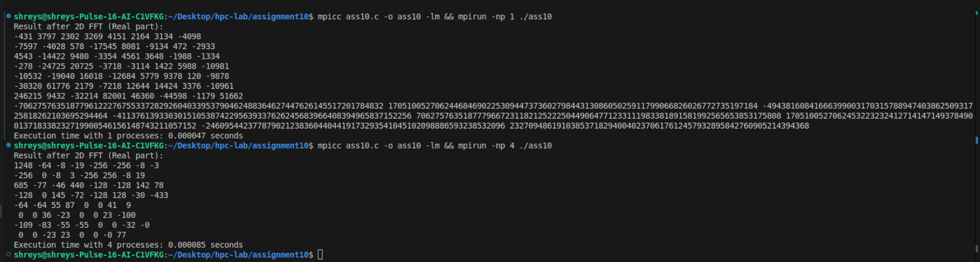

**Problem Statement 2:**

Repeat problem 2 above with varying message sizes for reduction (Program B). Explain the observed performance of the reduction operation.

**Screenshot:**

#include <stdio.h>

#include <stdlib.h>

#include <time.h>

#include <mpi.h>

int main(int argc, char *argv[])

{

if (argc != 2)

{

printf("Usage : reduce message_size\n");

return 1;

}

int rank;

int size = atoi(argv[1]);

char input_buffer[size];

char output_buffer[size];

MPI_Init(&argc, &argv);

MPI_Comm_rank(MPI_COMM_WORLD, &rank);

int i;

srand(time(NULL));

for (i = 0; i < size; i++)

input_buffer[i] = rand() % 256;

double total_time = 0.0;

double start_time = 0.0;

for (i = 0; i < 100; i++)

{

MPI_Barrier(MPI_COMM_WORLD);

start_time = MPI_Wtime();

MPI_Reduce(input_buffer, output_buffer, size, MPI_BYTE, MPI_BOR, 0, MPI_COMM_WORLD);

MPI_Barrier(MPI_COMM_WORLD);

total_time += (MPI_Wtime() - start_time);

}

if (rank == 0)

{

printf("Average time for reduce : %f secs\n", total_time / 100);

}

MPI_Finalize();

}

**Analysis:**

